**ASSIGNMENT-11.4:**

Write a pig script to find the count of each Hashtag in the dataset.

**Pig Script:**

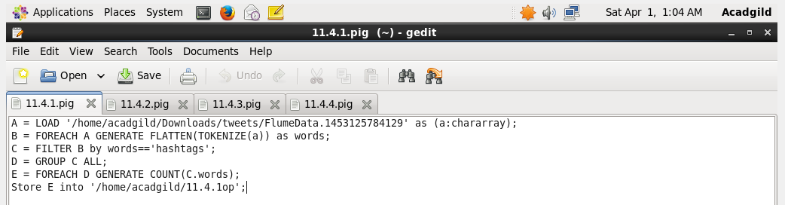

**Executing the Pig Script:**

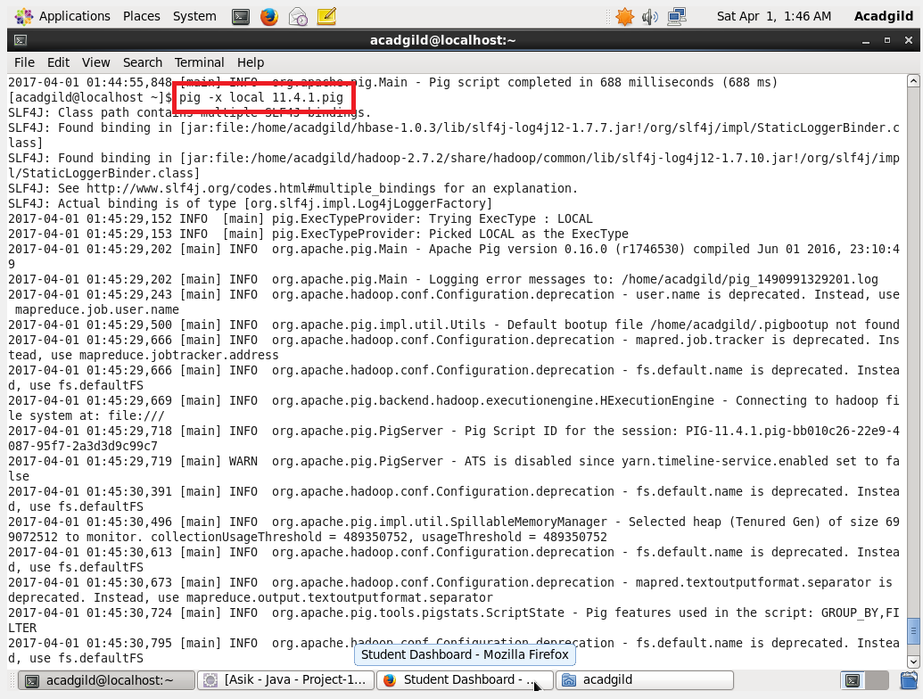

**Output:**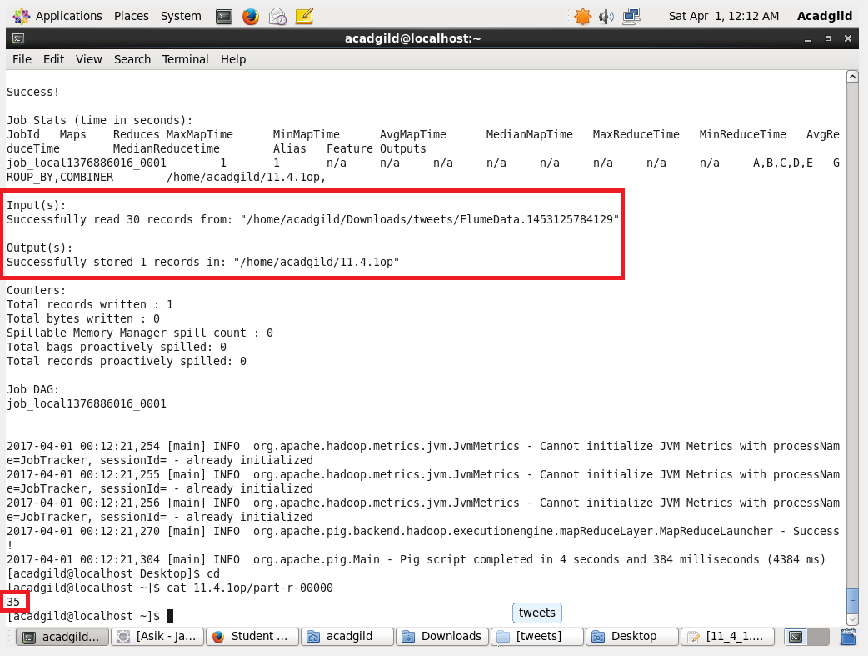

**Pig Script:**

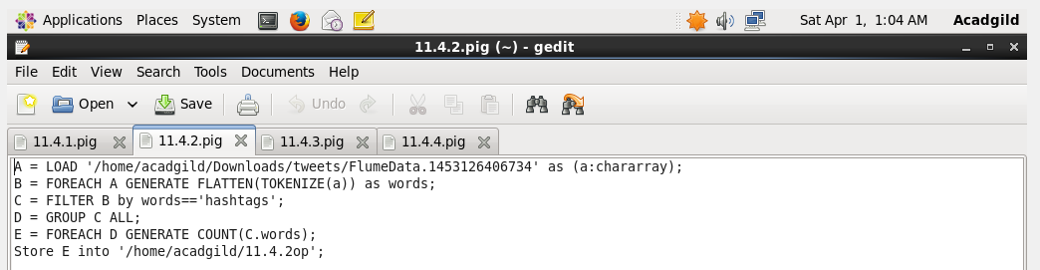

**Output:**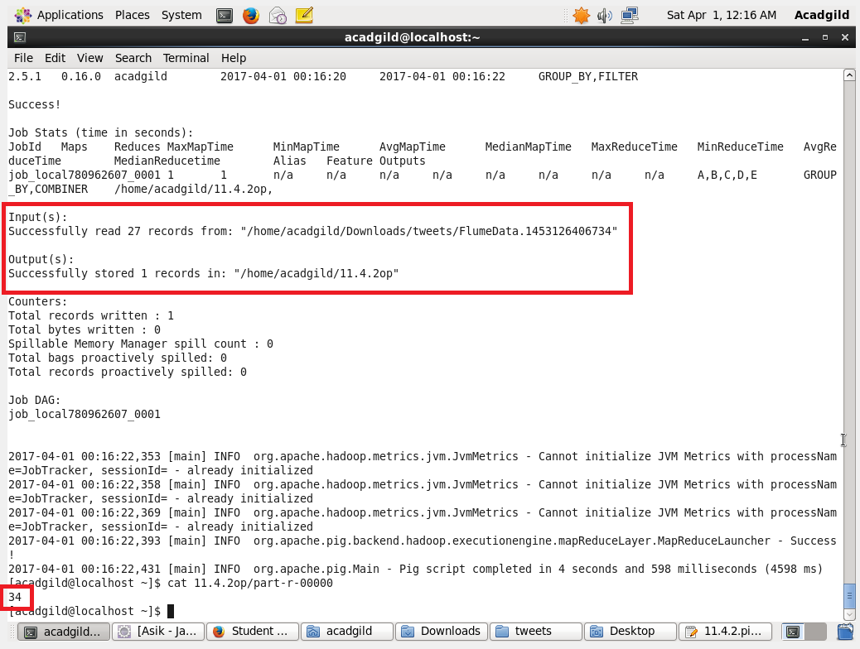

**Pig Script:**

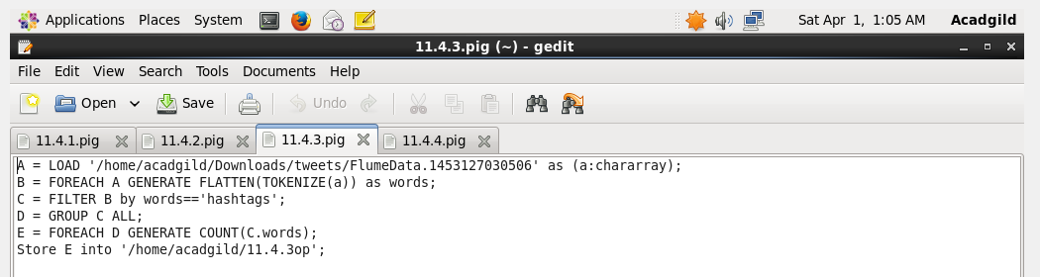

**Output:**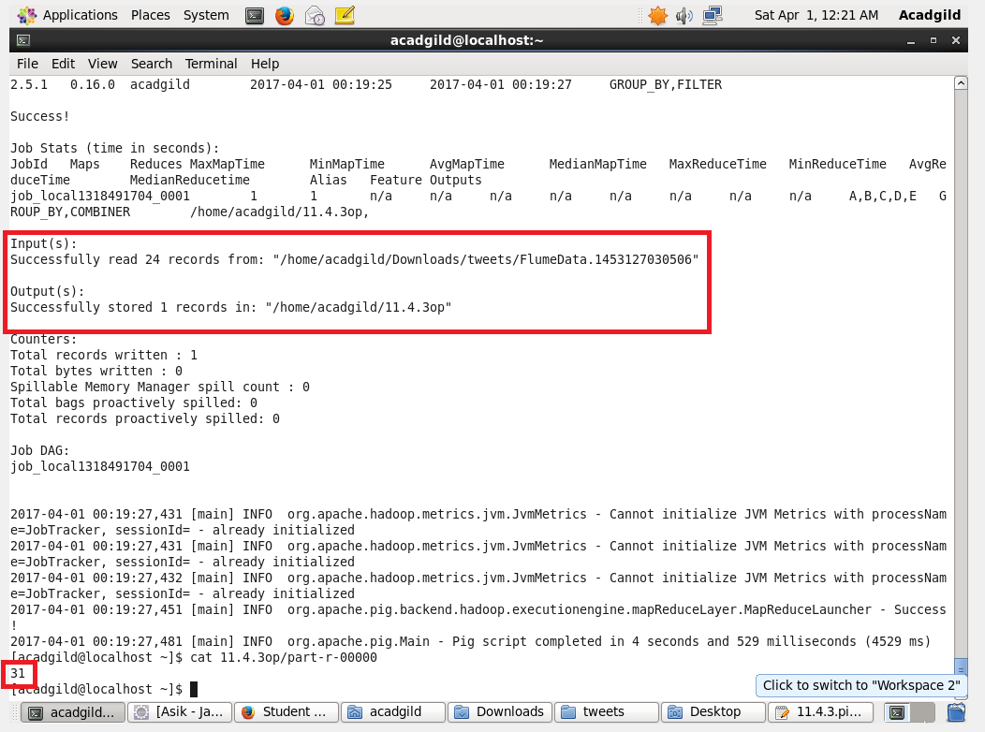

**Pig Script:**

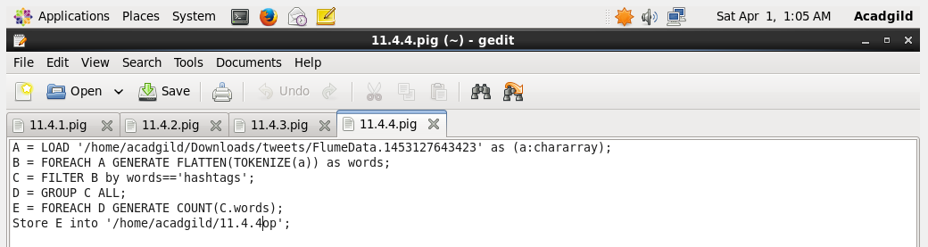

**Output:**